**Ideation Phase**

**Define the Problem Statements**

|  |  |
| --- | --- |
| Date | 28 September 2022 |
| Team ID | PNT2022TMID13566 |
| Project Name | Industry-specific intelligent fire management system |
| Maximum Marks | 2 Marks |

**Customer Problem Statement Template:**

Create a problem statement to understand your customer's point of view. The Customer Problem Statement template helps you focus on what matters to create experiences people will love.

A well-articulated customer problem statement allows you and your team to find the ideal solution for the challenges your customers face. Throughout the process, you’ll also be able to empathize with your customers, which helps you better understand how they perceive your product or service.

Reference: https://miro.com/app/board/uXjVPSAFtTs=/

**Example:**

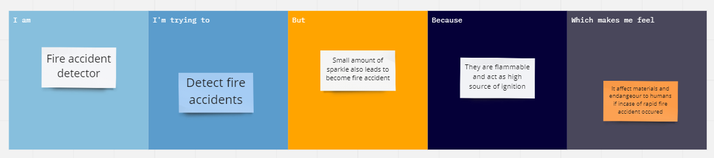

|  |  |  |  |  |  |
| --- | --- | --- | --- | --- | --- |
| **Problem Statement (PS)** | **I am** | **I’m trying to** | **But** | **Because,** | **Which makes me feel** |
| PS-1 | **Fire accident detector** | **Detect fire accidents** | **Small amount of sparkle also leads to become fire accident** | **They are flammable and act as high source of ignition** | **It affect materials and endanger to humans if in case of rapid fire accident occurred** |
| PS-2 | **Fire accident detector** | **To hire careful/experience employees in industry** | **Careless mistakes will affect whole industry** | **They are flammable and act as high source of ignition** | **If we done a work with careless method, it affect whole industry and their surrondings** |